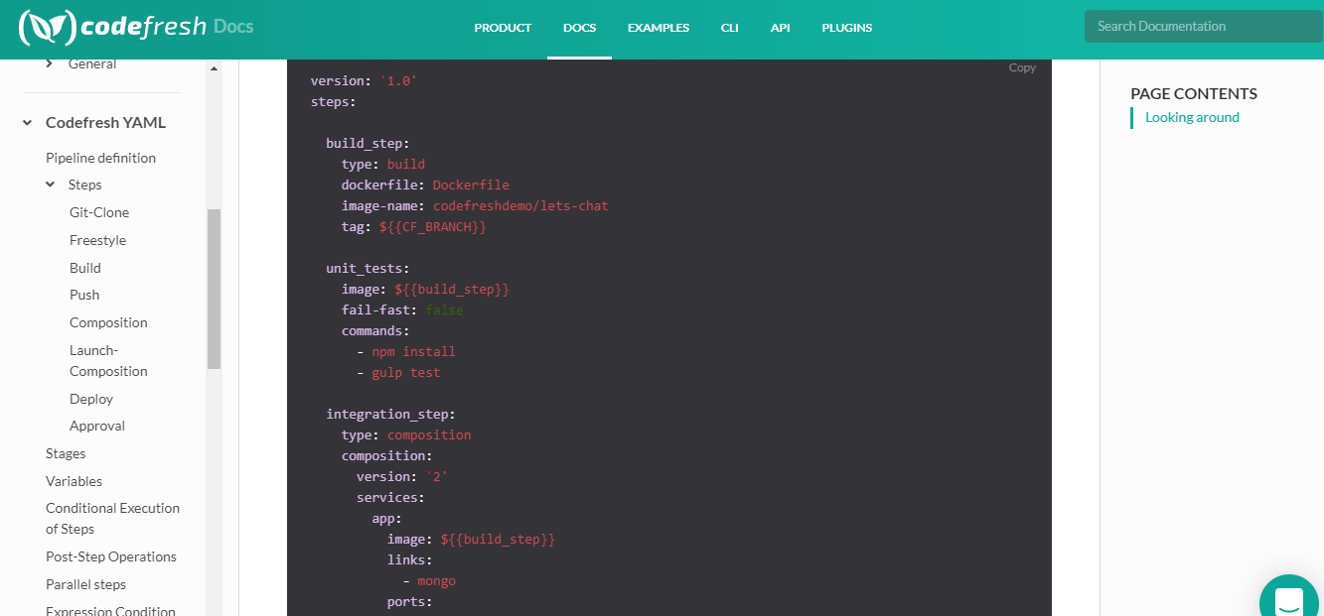

<https://codefresh.io/docs/docs/learn-by-example/nodejs/lets-chat/>

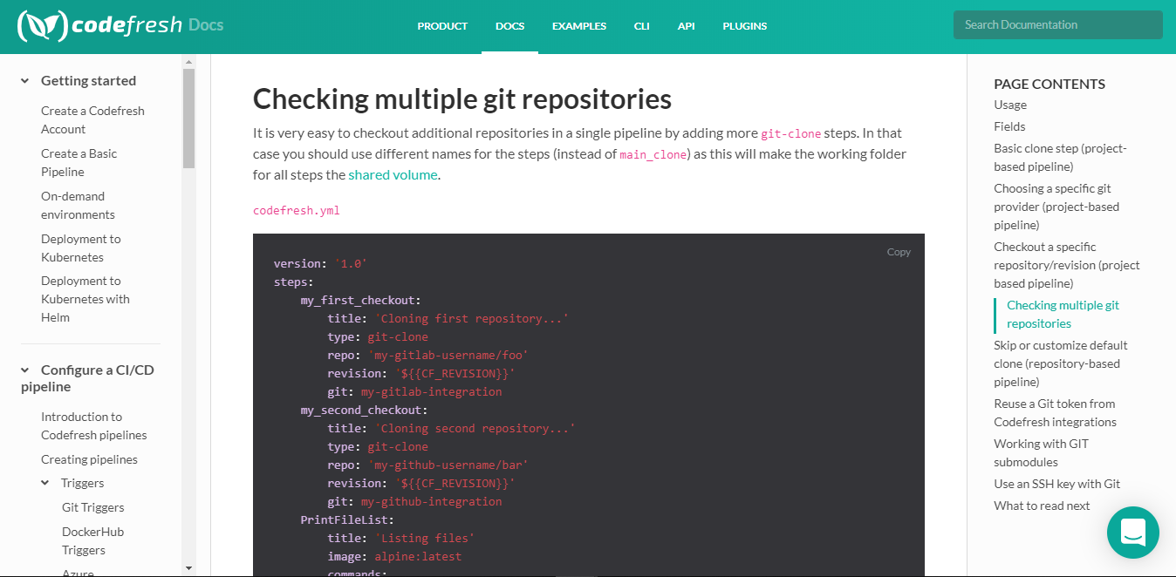

<https://codefresh.io/docs/docs/codefresh-yaml/steps/git-clone/#checking-multiple-git-repositories>

<https://codefresh.io/docs/docs/yaml-examples/examples/run-unit-tests/>

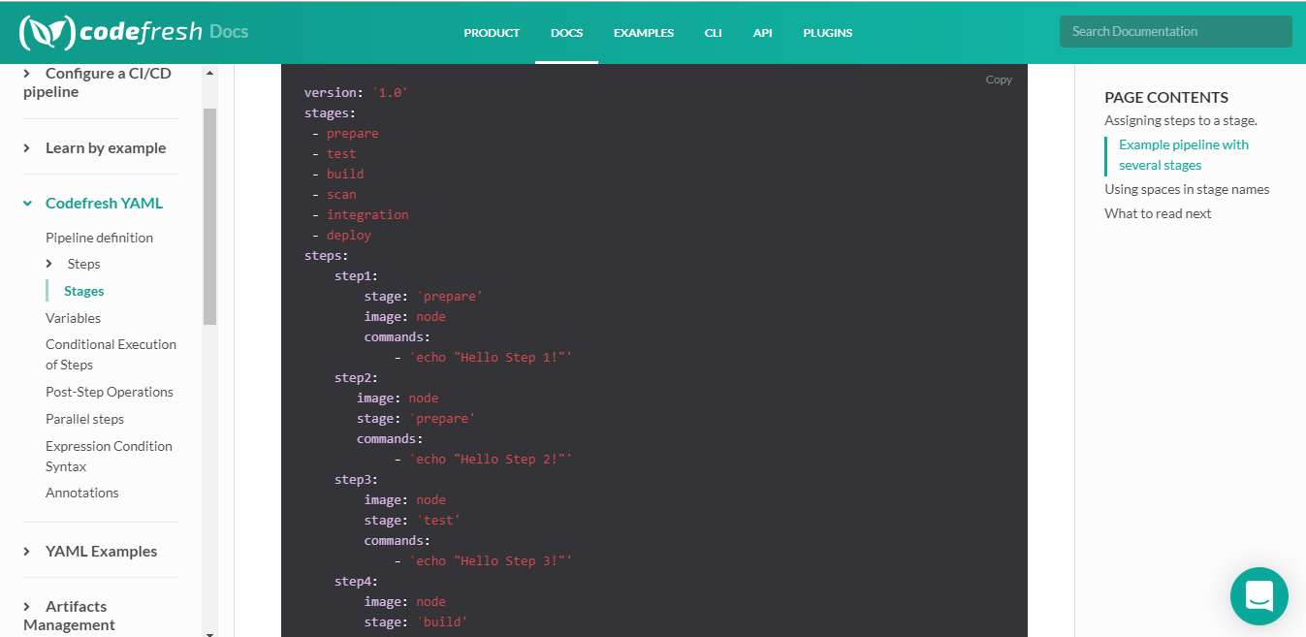

<https://codefresh.io/docs/docs/codefresh-yaml/stages/>

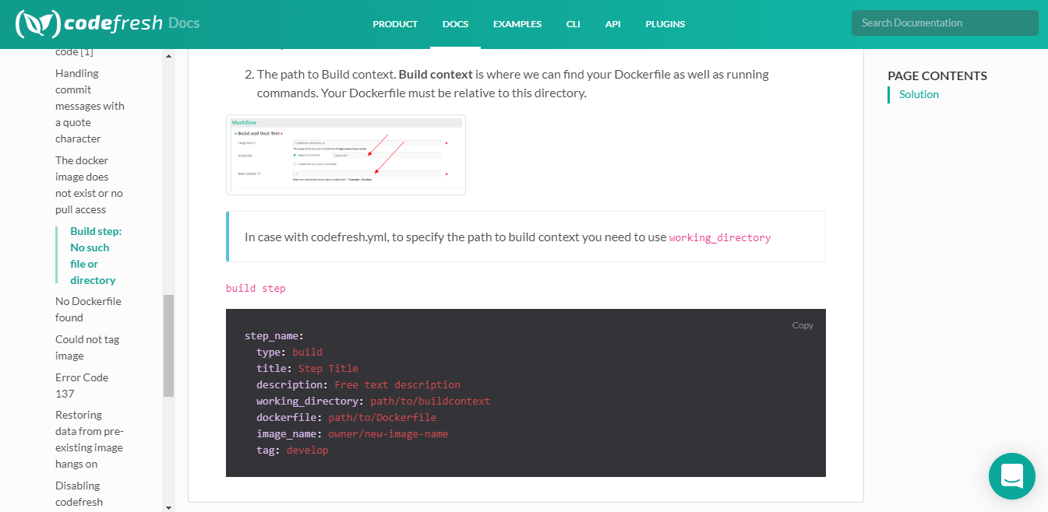

<https://codefresh.io/docs/docs/troubleshooting/common-issues/build-step-no-such-file-or-directory/>

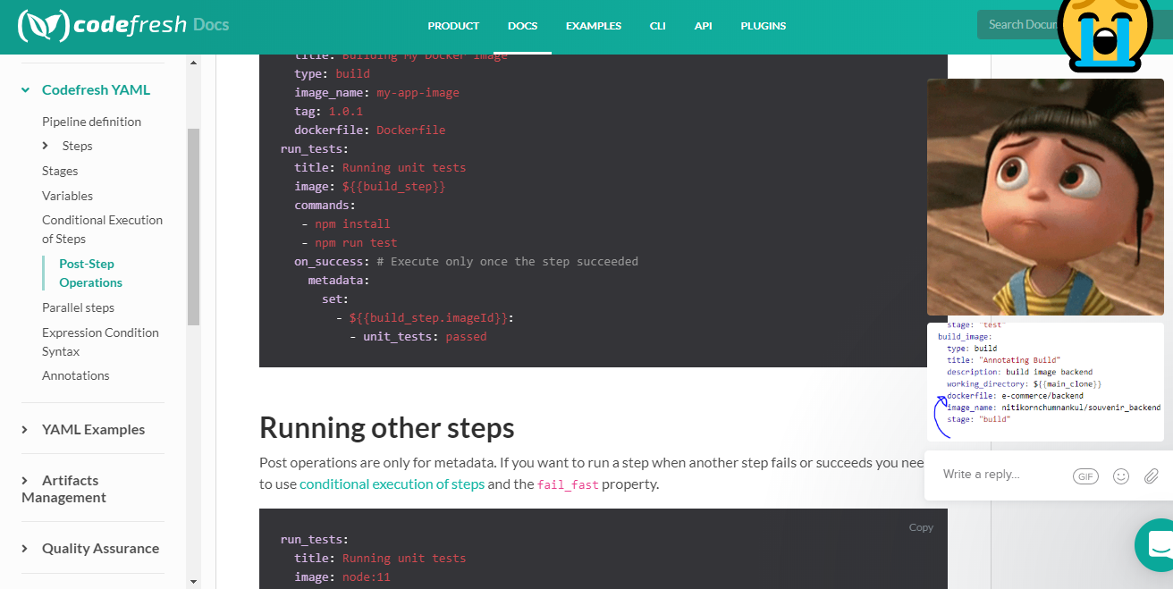

<https://codefresh.io/docs/docs/codefresh-yaml/post-step-operations/>